Attachment 1 Instructions for Proposal Upload

To submit a response to this solicitation, please follow the following steps:

- Go to the following link: http://www.procurement.virginia.edu/pagecontractopp .
- You will be asked to enter a “Code” for this Contract Opportunity. The code for this solicitation is “Videography-2018”.
- Click to Download the Contract Opportunity Agreement.
- Complete the downloaded form. Be certain you have reviewed the entire document and fulfilled all of the Conditions of Award.
**Note: Please complete the form/ document using Microsoft Word since other formats (i.e., Mac) will not format properly.
**Note: If you are not able to click on the URL links within the Contract Opportunity, you will need to copy and paste the URL links into your internet browser.
- Return to the above link.
- Re-enter the above “Code”.
- Click to Upload the Completed Opportunity.
- You will be asked two questions prior to being given the opportunity to upload a response;
  - Have you registered as a Vendor with the University and selected a payment method?
  - Have you registered with eVA?
**Note: Both registrations must be completed prior to submitting a response.
- After answering “Yes’ to both questions, complete the Vendor Information and File Sections of the online form. Be sure to upload a “Completed File” (response) and include any/ all “Additional Pricing Files”.
- Click the ‘Submit’ button to complete the response process for this solicitation. Please don't hesitate to contact me with any questions.
Any questions regarding the award process must be specifically addressed (via e-mail - preferred) to me at pur-rfp@eservices.virginia.edu. It is important that your firm provide all of the information detailed in the online form. Please fill the forms out completely, according to the instructions provided.

Responses are due no later than 3 P.M. E.D.T. on Wednesday, August 22, 2018. Thank you for your time and effort. The University looks forward to receiving your firm's response.
Sincerely, ToShun Campbell
Contracts Administrator

Screen Shots of the Contract Opportunity Process for Vendors

Accessing a Solicitation:

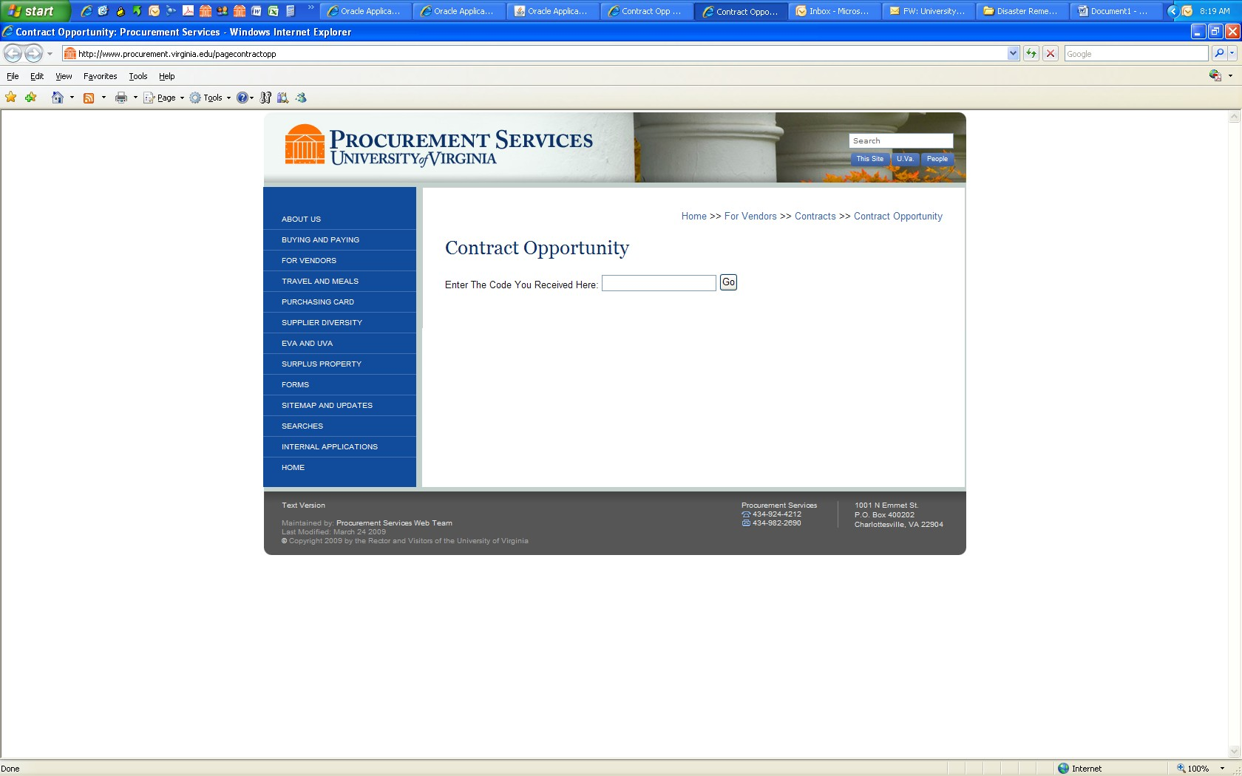

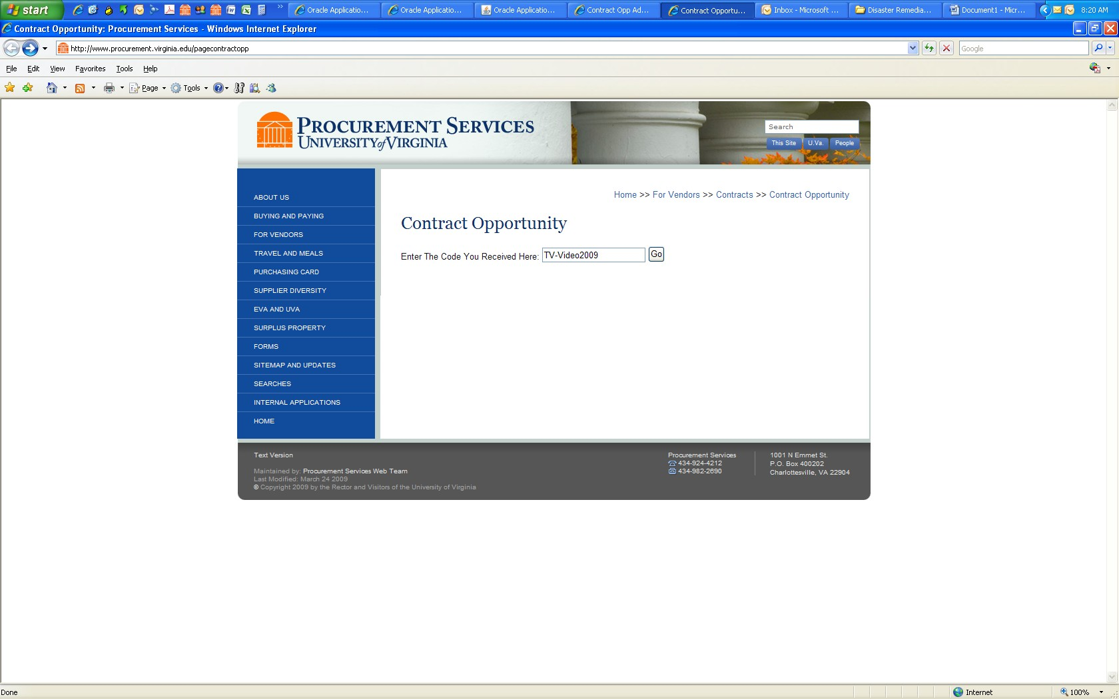

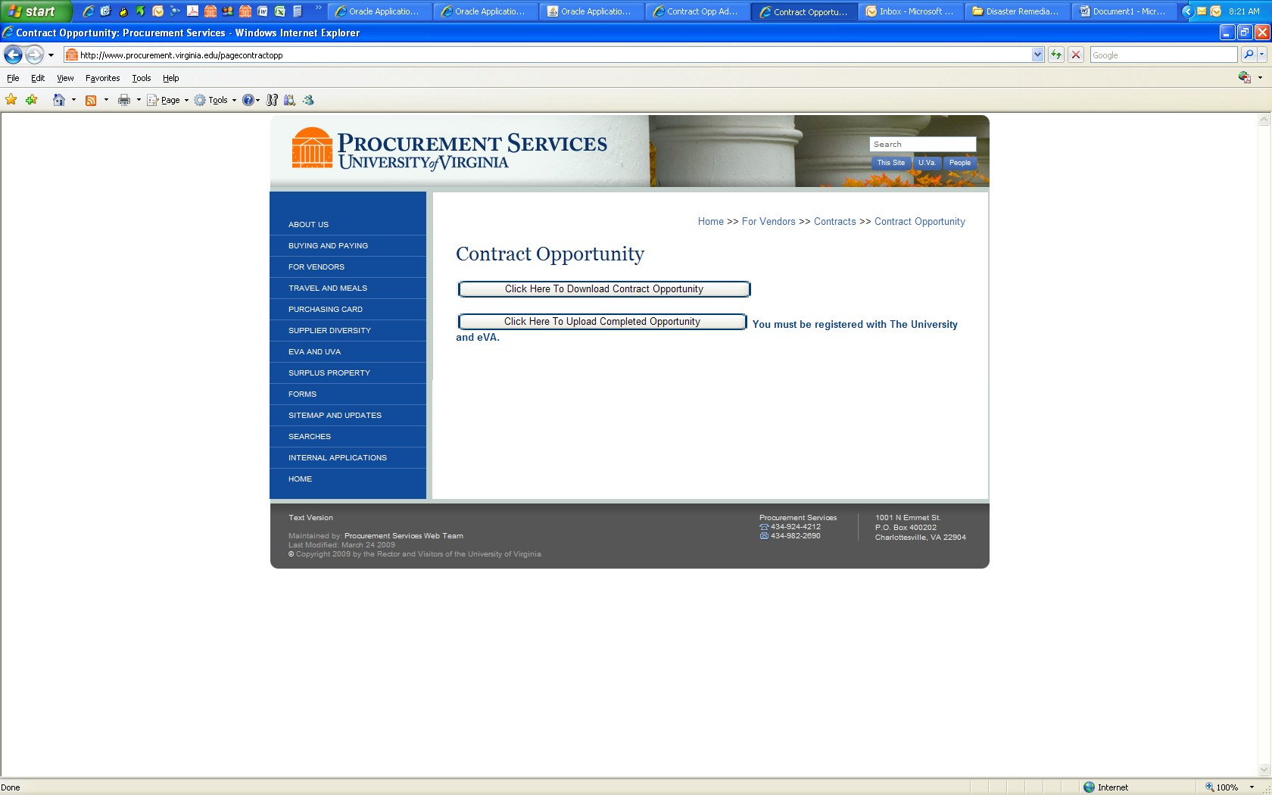

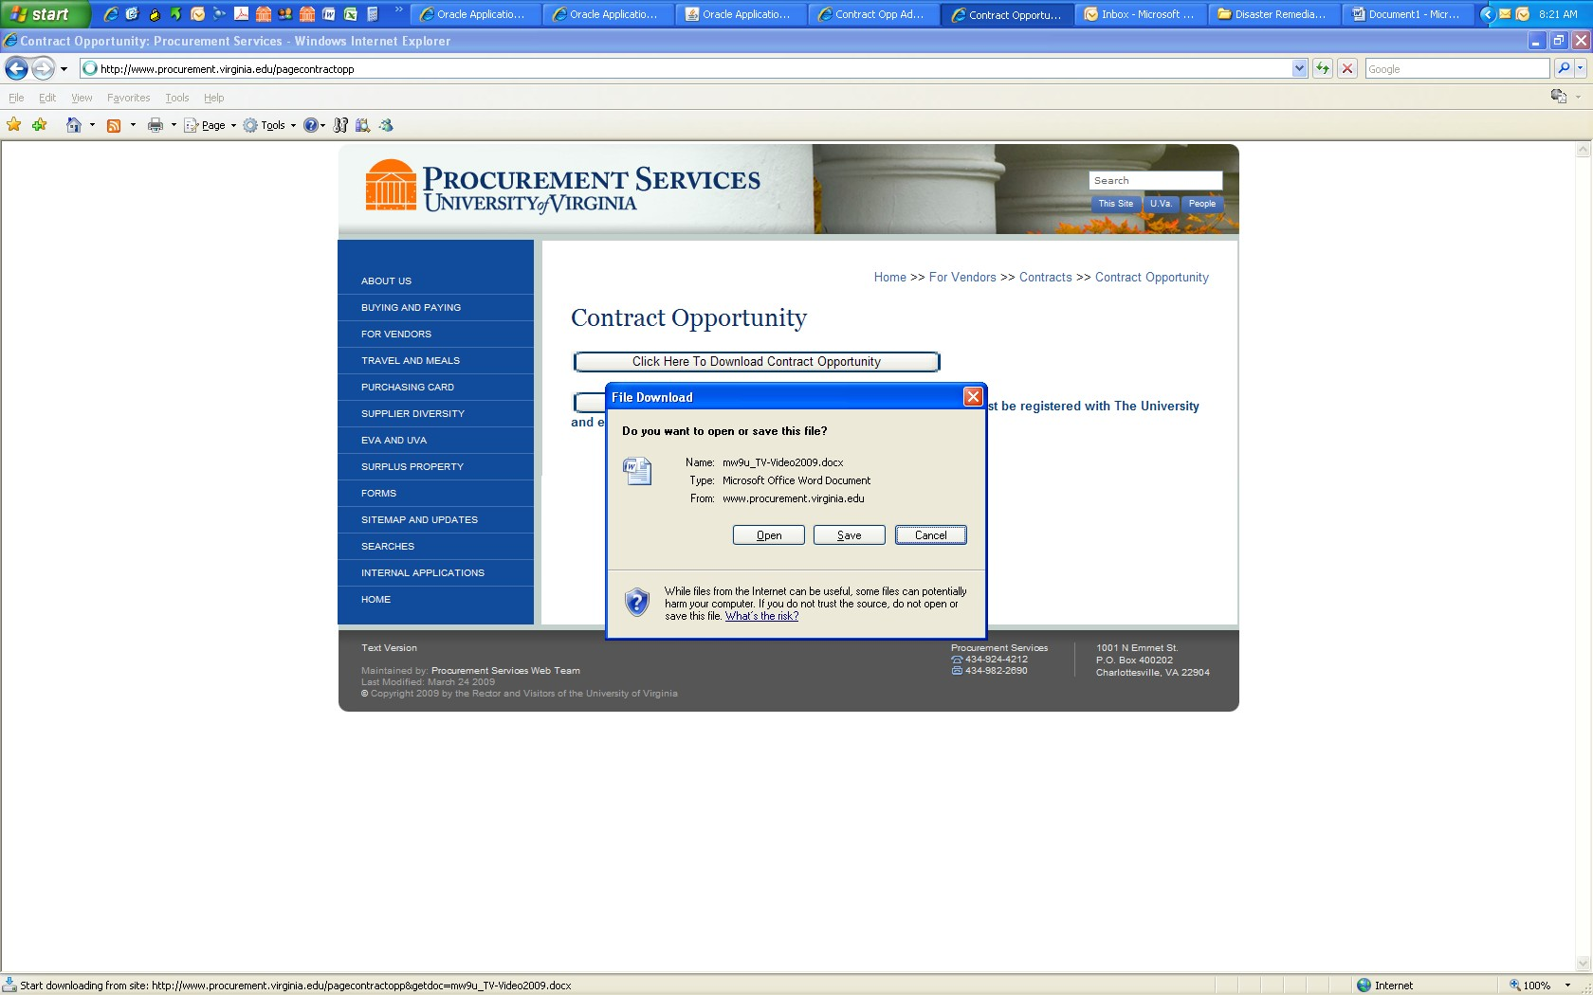

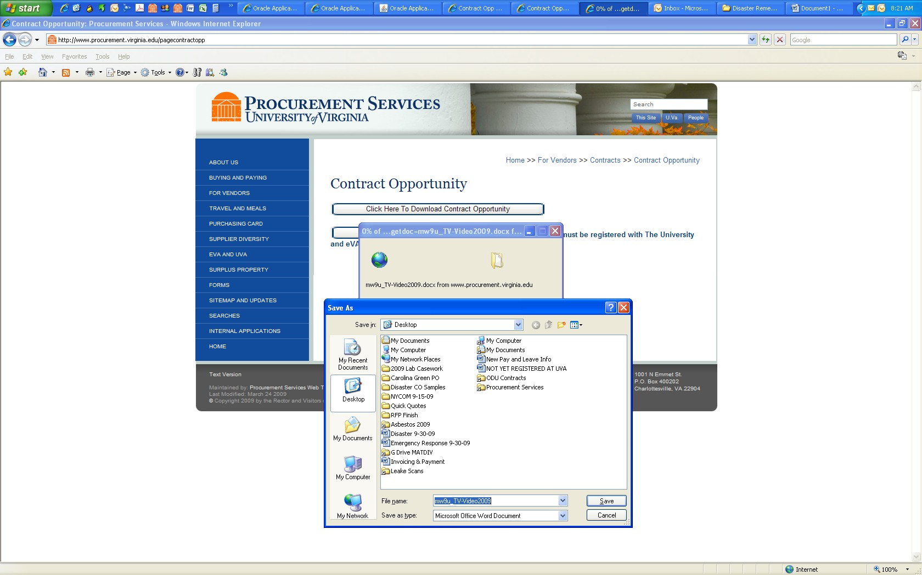

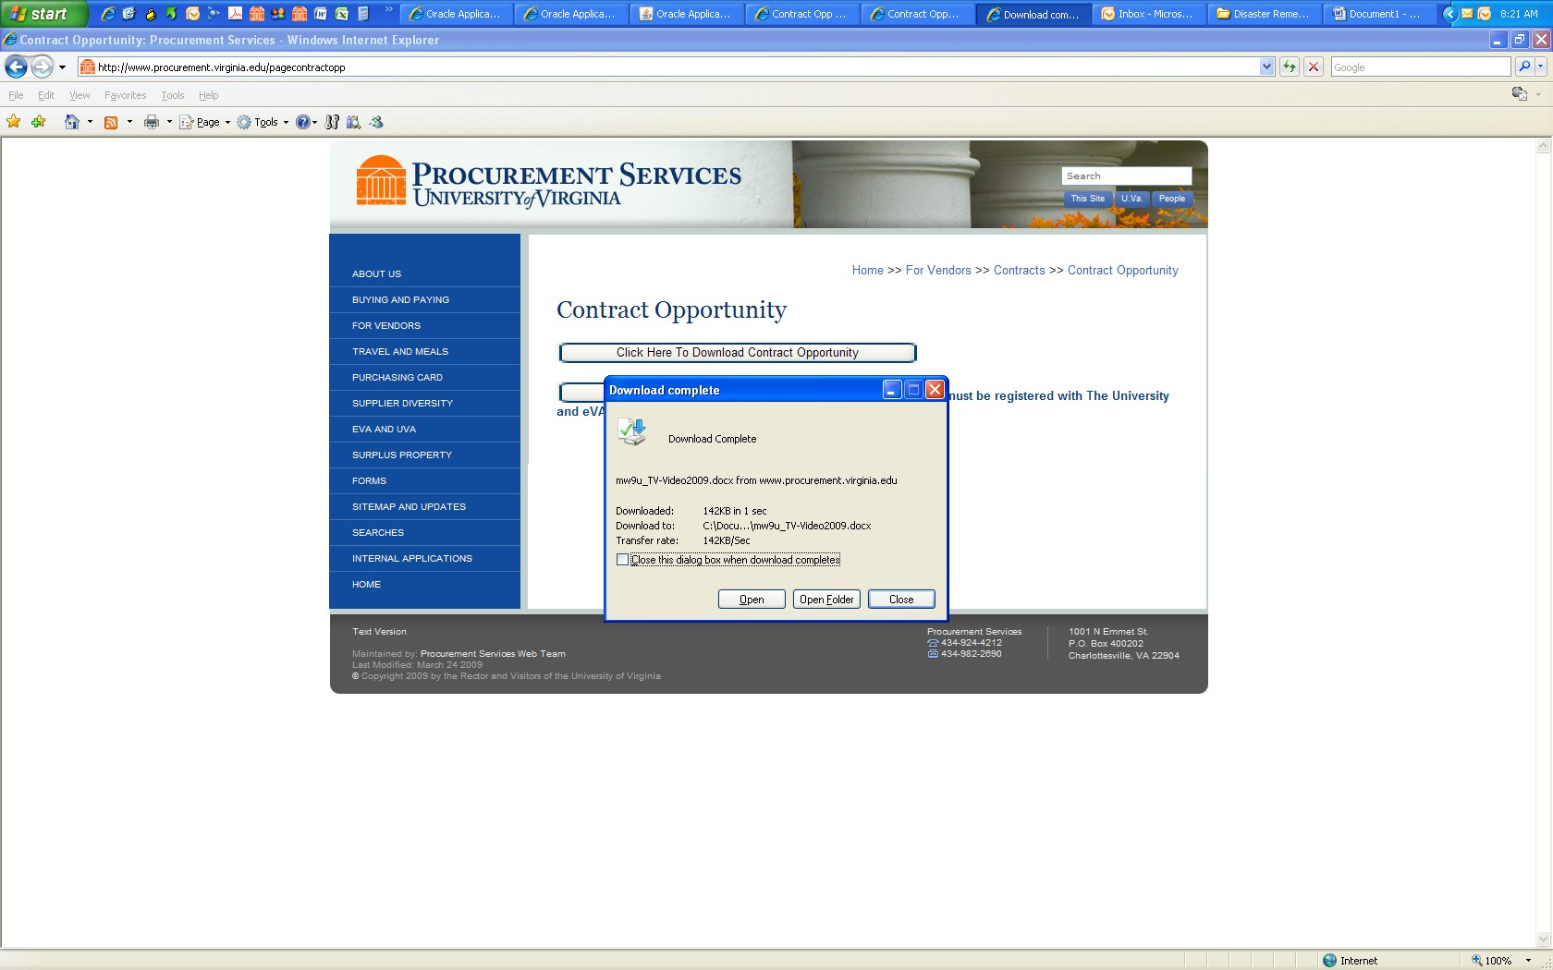

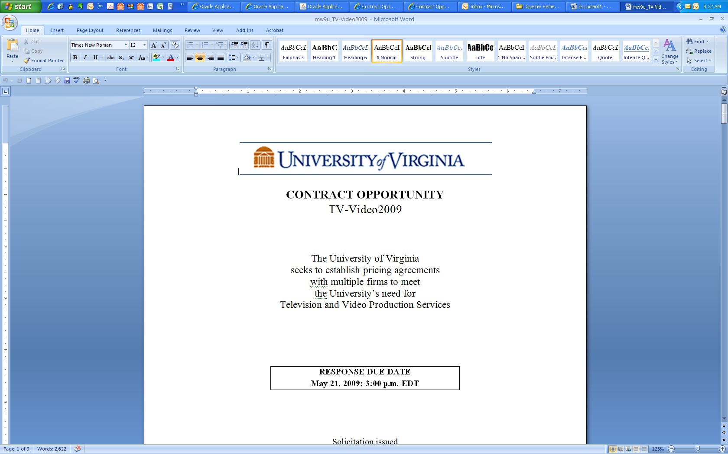

Uploading a Completed Contract Opportunity:

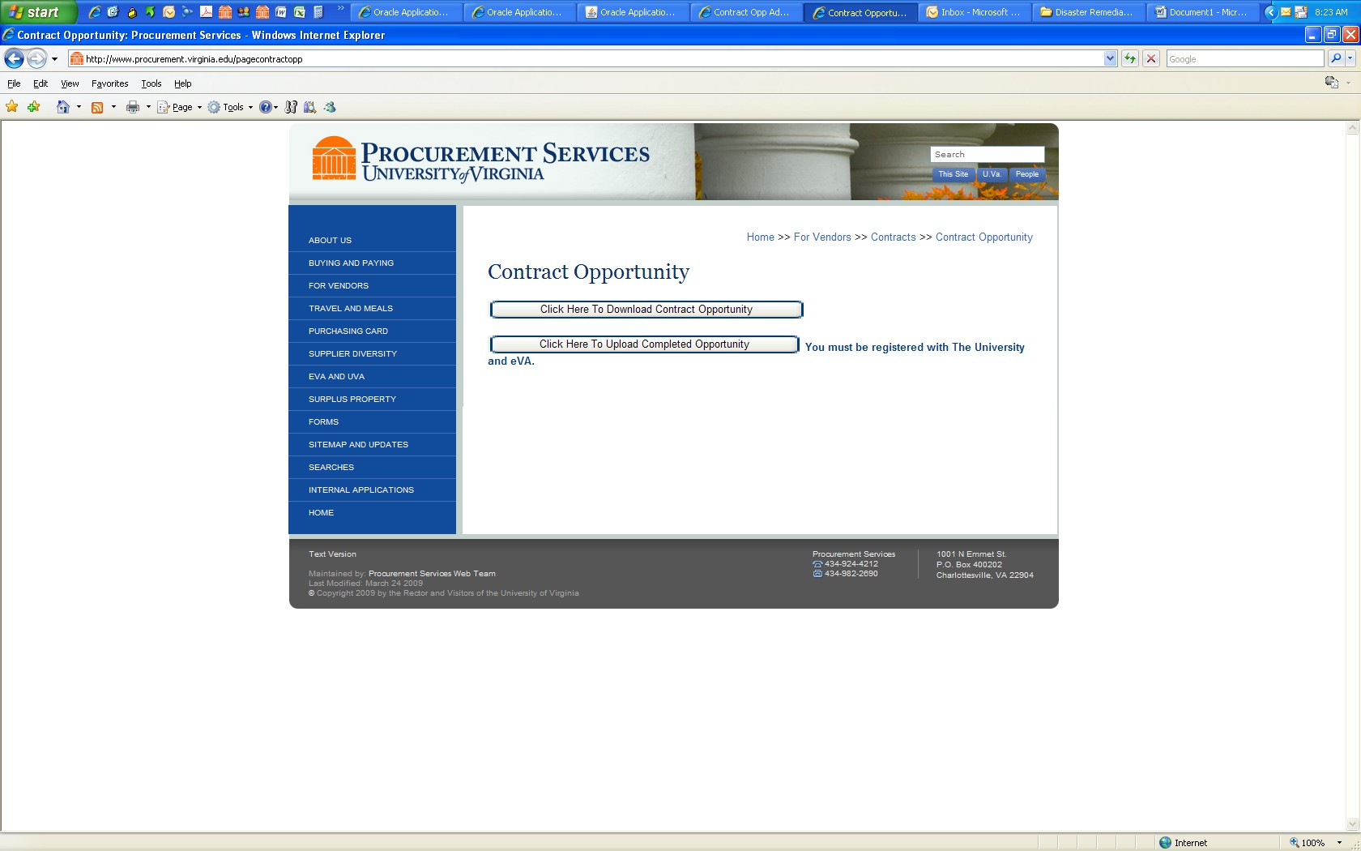

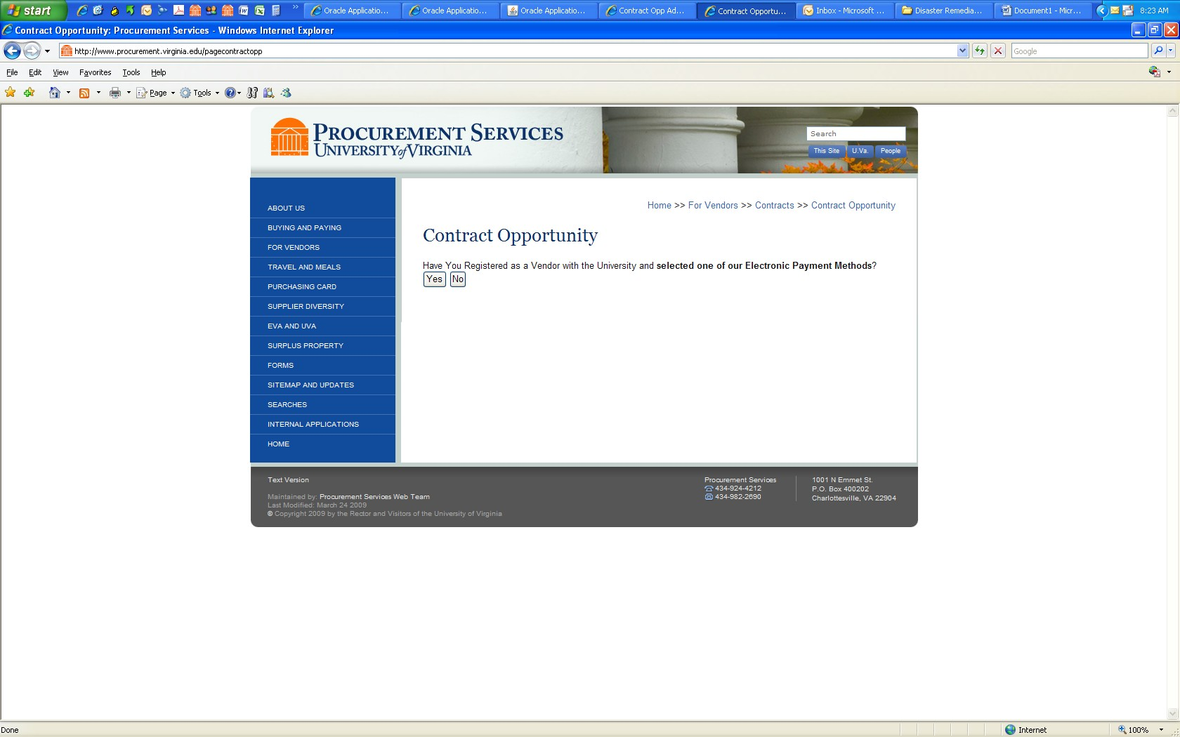

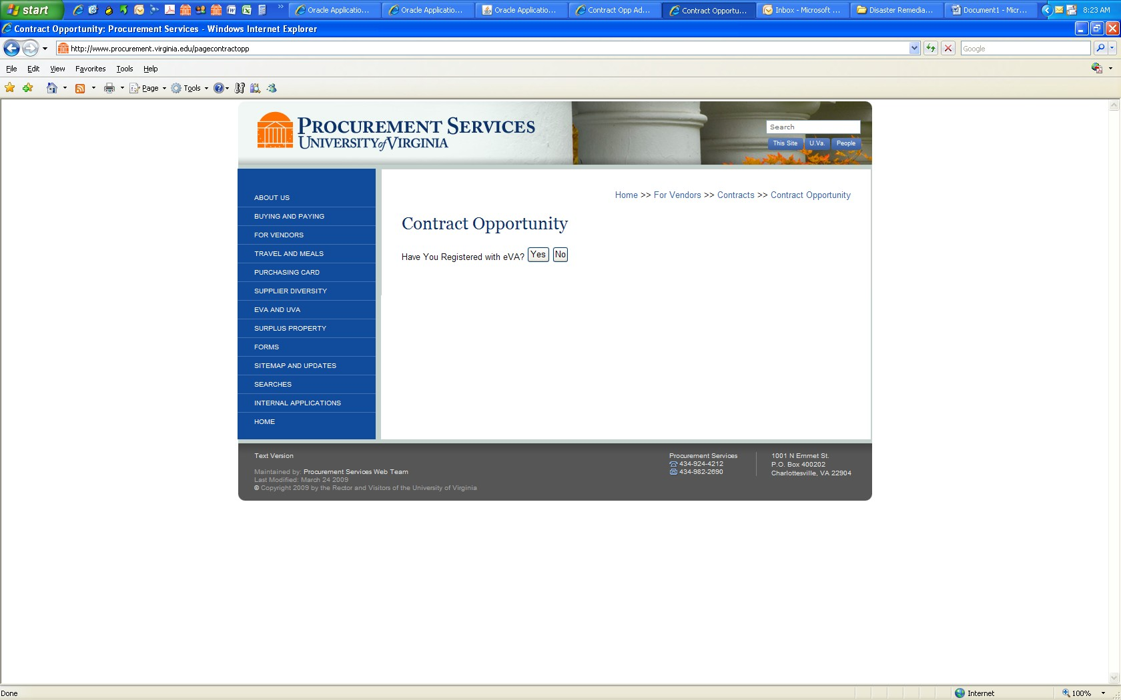

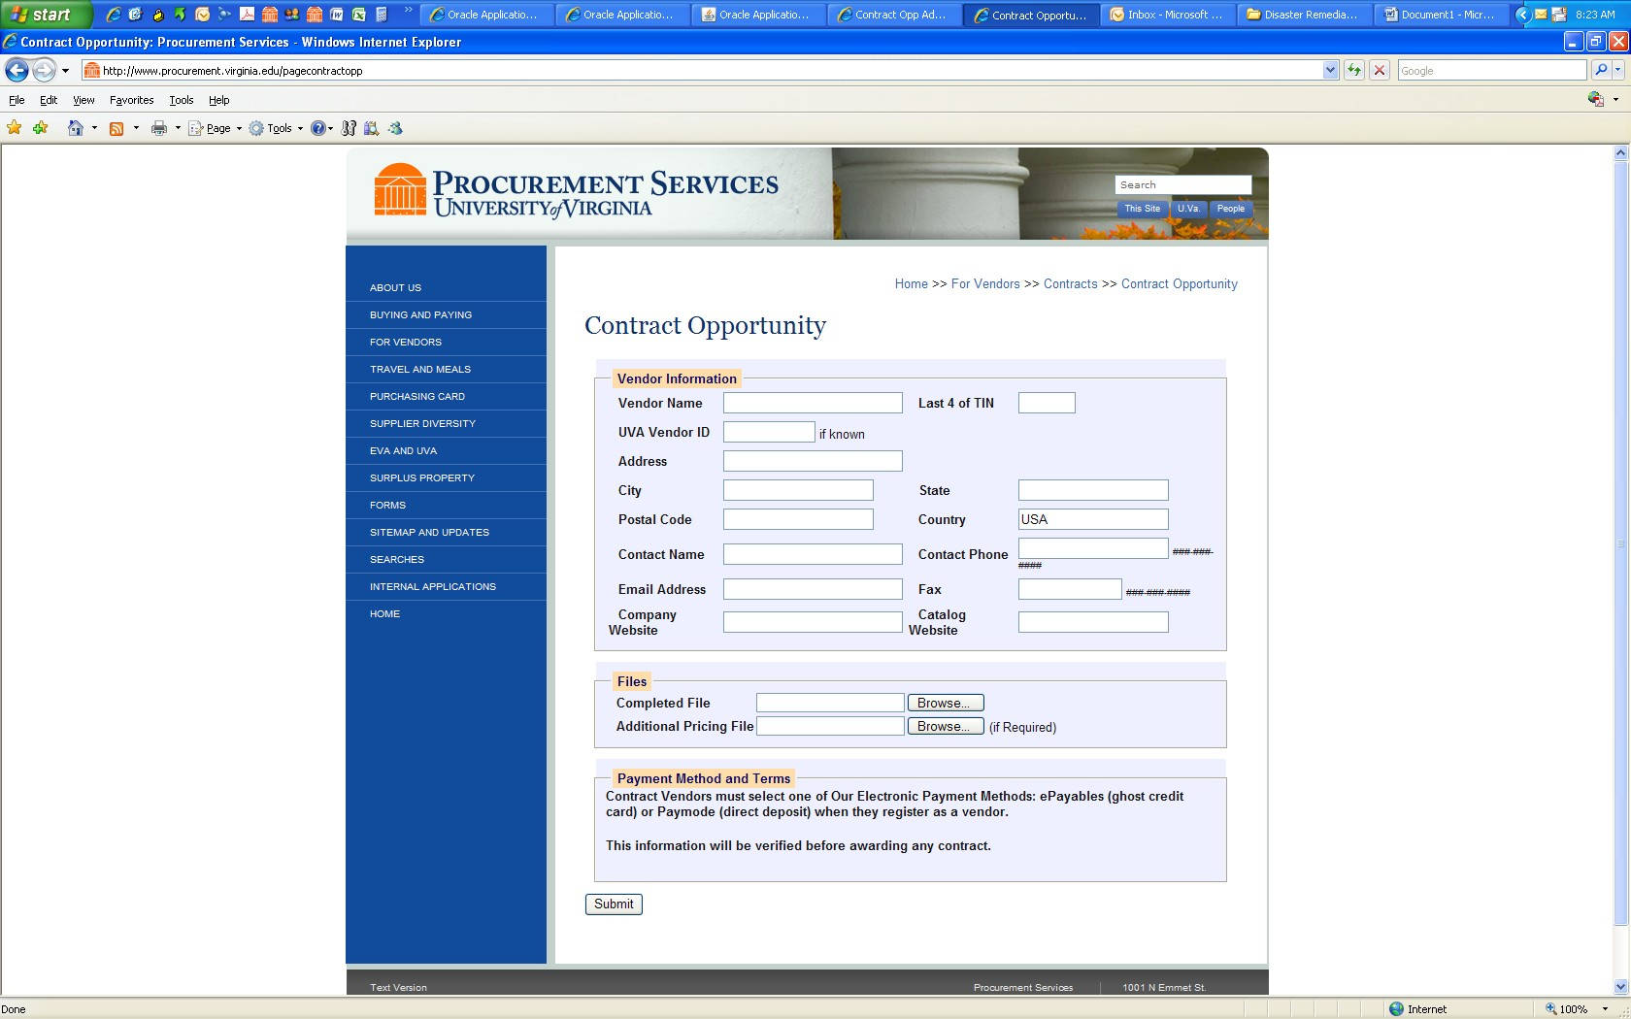

Clicking the ‘Submit’ button completes the response process for a Contract Opportunity.

