### INDEX7

Request for Proposal

#JG031918

Skilled Trades Services

Issued by

The University of Virginia

Procurement and Supplier Diversity Services

Charlottesville, Virginia



A VASCUPP™ Member Institution

Issued by

Procurement and Supplier Diversity Services

Charlottesville, Virginia

**I. GENERAL INFORMATION**

The University of Virginia (“University”) and its Facilities Management department are seeking to establish labor pricing agreements with multiple firms to provide Skilled Trades Services in electrical, mechanical, plumbing, carpentry, access controls, sprinkler systems, and specialty trades. The University is seeking firm(s) who provide services primarily and very limited additional products or parts cost.

The University will **not** be awarding to firms who provide professional services, painting, housekeeping, asbestos removal, landscaping, or other services recently covered by a University issued solicitation. These services are procured under separate solicitations with special conditions and work performance criteria included.

Firms meeting the requirements of this solicitation (“Selected Firms”) will be issued a Letter of Award and assigned a contract number for future reference. Any firm not a part of this original solicitation that meets the requirements as specified herein may be added at a future time at the sole discretion of the University. This RFP includes an annual open enrollment period that allows proposals to be considered after the first generation of awards are made.

**The proposal due date is** **3:00 PM EDT April 23, 2018** for this first generation of awards. The term of awards will be five (5) years effective upon execution of an Agreement, with the ability to renew on the same or similar terms and conditions, for five (5) additional years until April 23, 2028**.**

Firms must submit an electronic proposal that will be received by the University by the proposal deadline. Proposals must be submitted through the Contract Opportunity Portal found online at <http://www.procurement.virginia.edu/pagecontractopp> - **Use code JG031918**. The University may, at its discretion, accept late proposals if it is determined to be in the best interest of the University. See RFP Attachment 1: Sample Screen Shots for Proposal Upload, for instructions on submitting proposal

In order to meet the requirements for an award, the firm must respond by completing the following documents with the requested information. Please note that forms should only be completed as a Microsoft or Adobe pdf fillable forms. Proposals submitted in any other format may delay award of an Agreement. Any questions should be **directed to the address listed below.**

**Response requirements**

A. This RFP with the requested information provided to demonstrate that the firm can meet the requirements listed in the Scope of Goods and Services.

B. Submission of a signed Master Services Agreement confirming agreement to all terms and conditions by checking all boxes and responses to each fillable field.

C. Provides all required firm information, Section III.

D. A copy of your Virginia Contractors License.

Note: Any exceptions taken or additions to the terms presented herein may cause the firm’s response to be deemed non-responsive. No Letter of Award will be issued until a firm meets these response requirements.

Please note that the University makes no guaranteed minimum amount of purchase or future business with the issuance of a Letter of Award. University departments may, but are not required to, seek competition. University departments will request, and be provided by the Selected Firm(s), a detailed statement of work and price quotation prior to project. Selected Firms will then be provided with a University Purchase Order for each individual project.

|  |
| --- |
| **Refer all questions to:** University of Virginia Department of Procurement and Supplier Diversity Services  1001 North Emmet St, Carruthers Hall  P.O. Box 400202  Charlottesville, VA 22904-4202  Attention: John Gerding  Phone: 434-982-2563  Fax: 434-982-2690  Email: [jeg5y@virginia.edu](mailto:jeg5y@virginia.edu)  NOTE 1: The University does not take responsibility for lost or misdirected email.  NOTE 2: During the RFP process, all communication must be directed to the buyer listed above, with the exception of issues directly |

**II. SCOPE OF SERVICES**

The University seeks experienced firm(s) to provide a broad range of firms who provide services on the grounds of the University, primarily in the electrical, mechanical, plumbing, carpentry, access controls, sprinkler systems, and specialty trades. The University will not be awarding to firms who provide professional services, painting, housekeeping, asbestos removal, landscaping, and snow removal. These services are procured under separate solicitations with special conditions and work performance criteria included. Firms do not need to possess experience in all categories to respond but should provide an overview of capabilities in the response. Firms can only provide services for contractors endorsements their firm possess.

Specific project requirements will be provided by the requesting department at the time services are needed.

**III. FIRM INFORMATION**

**A.** **Brief history of the firm**:

Click here to enter text.

**B**.  **Client Reference List**

Provide at least one business reference.

|  |  |
| --- | --- |
| 1 Reference Name | Contact |
| Address | Phone #: |
| E-mail address |  |
| Description and date(s) and services provided | |

**C.** **Experience**

Provide Curriculum vitae, Resumes or capabilities statement for all personnel that may be assigned to the University. Include relevant experience or certifications:

Click here to enter text.

**D**. **Small, Woman-Owned or Minority-Owned Status**

**Is your firm** [SBSD Certified](https://www.sbsd.virginia.gov/)**?** **Yes**  **No**

**If yes, which category:** Small Business  Minority-Owned Women-Owned

**E**. Provide any other information which the University should consider in evaluating the firm's proposal:

Click here to enter text.

**Master Services Agreement**

This Agreement, effective Click here to enter a date. , is by and between the Rector and Visitors of the University of Virginia, (the “University”) and Click here to enter text. (“Selected Firm“).

**TERM**

The term of this Agreement will be for five (5) years effective upon execution of this Agreement, with the ability to renew on the same or similar terms and conditions, for Five (5) additional one year periods until April 23, 2028. Unless otherwise determined by the University or Selected Firm, this Agreement will automatically renew without intervention between the University and Selected Firm. The University and Selected Firm reserve the right to negotiate price of goods and services on an annual basis.

**WITNESS**

By its Request for Proposal (RFP) JG031918 for Skilled Services dated March 20, 2018, the University requested proposals from firms to provide Skilled Services (the “Goods and Services”). The parties, having negotiated concerning the Goods and Services wish to express in this Agreement the basis on which the Selected Firm will provide the Goods and Services to the University. Accordingly, and in consideration of the mutual premises and provisions hereof, the parties hereby agree as follows:

**1**. **Contents**

These documents are hereby incorporated into this Agreement:

1. The RFP dated March 20, 2018; and
2. Selected Firm’s proposal in response to RFP JG031918 and any other additional documents submitted by the Selected Firm.

To the extent that the terms of the various Agreement documents are in conflict, the terms of this Agreement, prevail over all other Agreement documentation.

**I. CONDITIONS OF AWARD**

Please check each box below confirming agreement with the conditions of award. **Terms that contain a check box must be checked to confirm Agreement acceptance.**

1. **Contractual Provisions**

The Selected Firm agrees to the following terms and conditions: Alterations will NOT be accepted to Mandatory or Purchasing Terms and Conditions.

**The University’s Mandatory Contractual Provisions:**

<http://www.procurement.virginia.edu/main/publicpostings/rfp/mandatoryprovisions.pdf>

**The University of Virginia Purchasing Terms & Conditions:**

<http://www.procurement.virginia.edu/pagepterms>

**The University’s Preferred Contractual Provisions:**

<http://www.procurement.virginia.edu/main/publicpostings/rfp/preferredprovisions.pdf>

If a firm has any modifications to any of the Preferred Contractual Provisions you must submit a separate document with your proposal titled “**Firm Name - Contractual Provisions Addendum**” with the proposed contractual provision modifications listed/numbered to correspond with how the provisions are listed in the hyperlinks within this document.  This document must be a Word document.  The University reserves the right to accept, reject, or modify the proposed modifications.  Please be advised that any requested modification to the contractual provisions could delay and/or impact an award to a firm.  If the firm does not submit a separate addendum, then the proposal from the firm will automatically be deemed to include University Contractual Provisions.

**The Selected Firm acknowledges that it is aware of The University's Procedure for Resolution of Contractual Claims** <http://www.procurement.virginia.edu/main/publicpostings/rfp/resolution.pdf>

**The Selected Firm agrees to register as a vendor in the University’s** Vendor Registration portal <https://www.procurement.virginia.edu/main/frms/VendorReg.php>

**The Selected Firm is registered or agrees to register with in the Commonwealth of Virginia’s electronic procurement system, eVA (Information on eVA can be found at:** [**http://www.eva.virginia.gov**](http://www.eva.virginia.gov)**) and agrees to maintain its registration for the term of this Agreement**

|  |  |
| --- | --- |
| **eVa Registration Number:** |  |

**The Selected Firm will** provide a detailed statement of work prior to any project summarizing specific services, deliverables, delivery dates and cost. – Without additional terms or conditionsrequiring University signature. The University has a signatory authority policy that allows only specified individuals to sign contracts.

**The Selected Firm will** accept a University issued Purchase Order as the commitment to start a project and will not start work on the project until a Purchase Order is received.

**Invoicing**

The Selected Firm will provide detailed invoices with hours worked and service rates to the requesting department and follow the invoice instructions on University Purchase Orders. The Selected Firm agrees to not invoice for more than the amount of services committed to by University Purchase Order and will not require a prepayment or deposit. Progress invoices are permissible if provided after completion of work and payable within agreed upon payment terms. .

**Payment**

The University’s payment terms are Net 45 from receipt of invoice or services whichever is later**.** The University encourages Selected Firms to consider expedited pay terms for a discount. Multiple early payment discount terms are available. If applicable, please select an early payment discount term below.

2% 15 days / Net 30 days

1.5% 20 days / Net 30 days

1% 30 days / Net 45 days

Net 20 days using E-Payables or Paymode – X*

Other

**\*** Requires registration with the University’s banking provider, Bank of America for these electronic payment methods <http://www.procurement.virginia.edu/pagepaymentmethods>

**Insurance**

The Selected Firm agrees to maintain the following insurance from companies that hold at least an A- financial rating with A.M. Best Company. The Selected Firm may be required to provide the University with a valid Certificate of Insurance before providing any goods or services to the University. The University reserves the right to approve any insurance proposed by the Selected Firm. In no event should the Selected Firm construe these minimum required limits to be its limit of liability to the University.

Commercial General Liability:

The Selected Firm(s) and any Subcontractor will provide a minimum combined single Limit of Liability for bodily injury and property damage of $1,000,000 per occurrence and a $2,000,000 aggregate with coverage for the following:

{X} Premises/Operations {X} Products/Completed Operations

{X} Contractual {X} Independent Contractors

{X} Additional Insured* {X} XCU Coverages

*The University will be named as an Additional Insured using the following proper name: "The Commonwealth of Virginia, and the Rector and Visitors of the University of Virginia, its officers, employees, and agents.”

Automobile Insurance:

The Selected Firm(s) and any Subcontractor will provide a minimum combined single Limit of Liability for bodily injury and property damage of $1,000,000 per accident with the following coverages for vehicles operated by their employees.

{X} Any Automobile {X} Owned and Non-Owned Automobiles

*If any design or consulting services are to be provided--*

The Selected Firm(s) and any Subcontractor providing professional services will maintain errors & omissions liability insurance with minimum limits of $1,000,000 per occurrence and $2,000,000 annual aggregate providing professional errors and omissions coverage covering the services as set forth in this agreement.

Workers Compensation:

The Selected Firm and any Subcontractor will maintain Workers' Compensation insurance in accordance with the Virginia Workers' Compensation Act, and also maintain Employers Liability insurance with limits of not less than $100,000.

*Additional Insured:

The University will be named as an Additional Insured, and the proper name is:

"The Commonwealth of Virginia, and the Rector and Visitors of the University of Virginia, its officers, employees, and agents."

**Services**

**The following services will be provided by the Selected Firm:**

Click here to enter text.

**Fees**

**The following pricing / Fees will be charged for the Services. The fee structure includes rates charged for all personnel or service that may be provided to the University.**

Click here to enter text.

The University prefers fully loaded rates inclusive of travel and expenses. If travel and expenses must be charge separately, these fees will not include a mark-up and must remain within the University’s per diem rates [**http://www.procurement.virginia.edu/pageconusrates**](http://www.procurement.virginia.edu/pageconusrates)

**Acceptance**

|  |
| --- |
| **Selected Firm Name** |

**This document will serve as the Master Services Agreement between your**

**Firm and the University.**

|  |  |  |
| --- | --- | --- |
|  | Representative Name: | Click here to enter text. |
|  | Title: | Click here to enter text. |
|  | Date: | Click here to enter a date. |
|  | **Electronic Signature**: By typing the name of the firm’s authorized representative/signatory into the field above the firm certifies that it is providing a binding “Electronic Signature” and further specifically validates that the individual affixing the Electronic Signature below is fully authorized to bind the firm with respect to the goods, services, pricing, terms and conditions listed herein. The Selected Firm will be issued an award letter if the University proceeds with issuance of an award. **This Agreement is not valid without an award letter**. | |

**Attachment 1**

UVAFinance

Vice President for Finance’s Request for Commitment

Greetings:

The University of Virginia is able to deliver excellent education, research, healthcare, and public service because the high value support from you and all our suppliers of goods and services. Thank you for sharing our commitment to excellence. As a University, we are committed to diversity within our students, our faculty and staff, and our vendors and contractors. An important part of our procurement program involves our commitment to doing business with small, women- and minority-owned (SWaM) businesses. We look to you to help us achieve this objective.

We currently have a substantial volume of activity with small firms; however, we are striving to increase the number of substantial, long-term business relationships with minority-and women-owned businesses. We need your help here.

I have two requests: First, I ask that you actively seek out opportunities to involve small, women-and minority-owned businesses as you deliver services to UVA. Our team in Procurement and Supplier Diversity Services will assist you in identifying qualified diverse business partners. Second, please report your success in this area through our quarterly subcontracting reports – this is critical in quantifying how well we are meeting our goals. The terms and conditions previously provided to your organization outlined this process.

This effort is important to the University. We truly appreciate your efforts to join us in this commitment and partnership towards excellence.

Sincerely,



Melody Bianchetto

Vice President for Finance

**Attachment 2**

**Sample Screen Shots for Proposal Upload**

***Sample Screen Shots of the for Contract Opportunity Portal***

***Accessing the Solicitation:***

<http://www.procurement.virginia.edu/pagecontractopp>

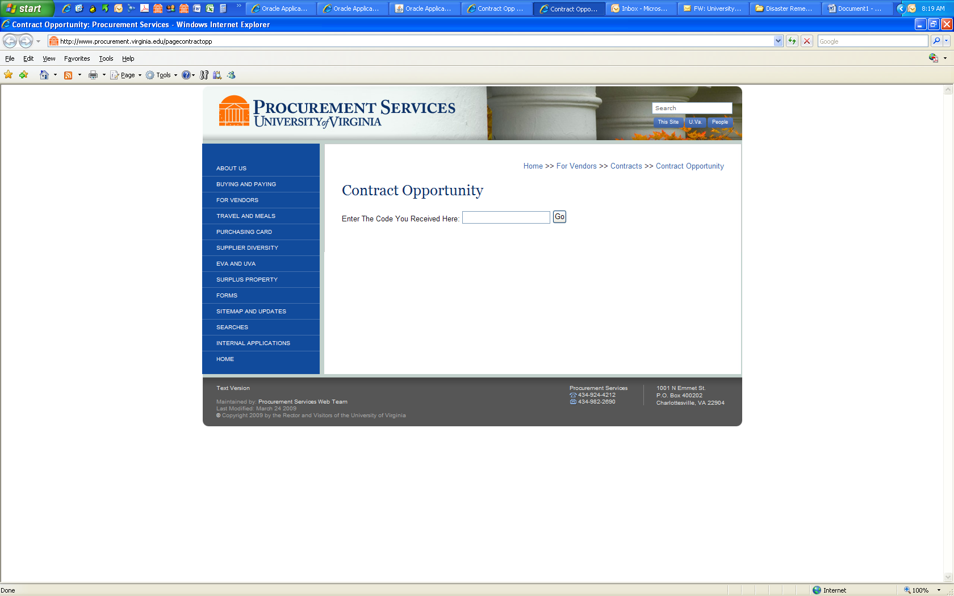

User will be prompted to enter the code **“JG031918”**

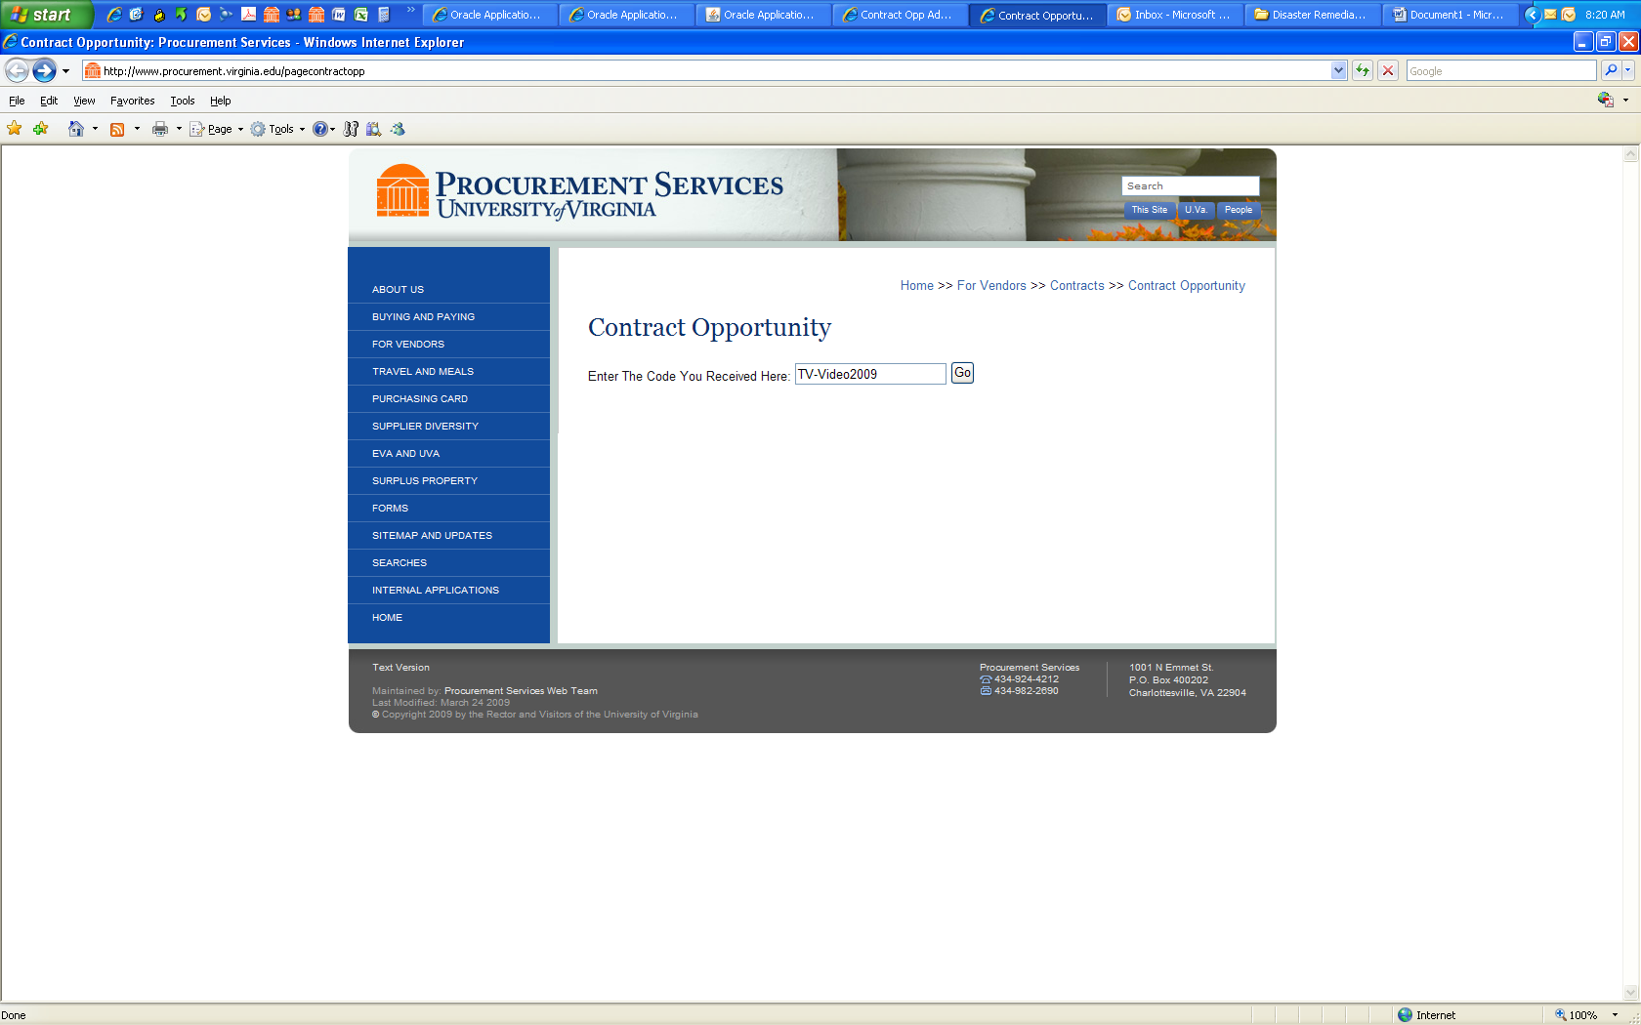

Select Click Here to Upload Completed Opportunity:

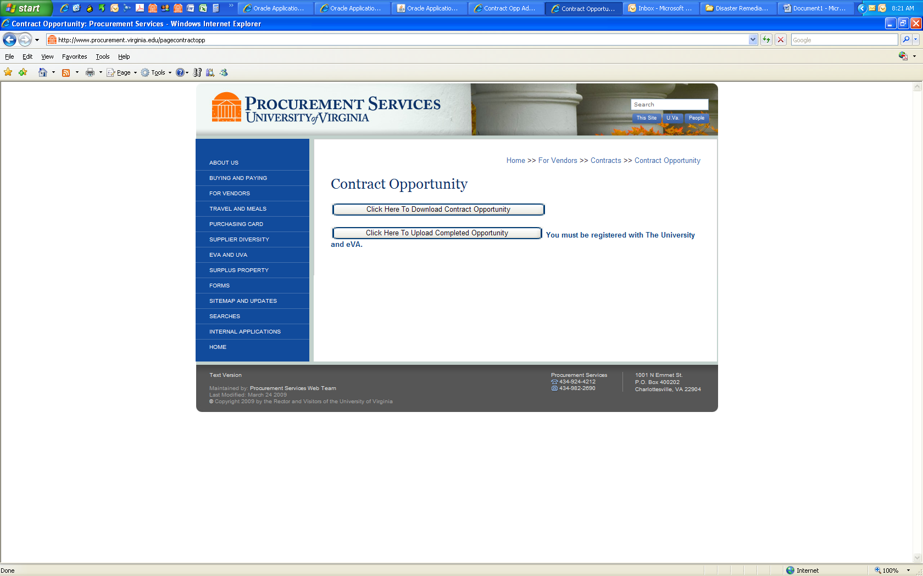

***Uploading a Completed CO:***

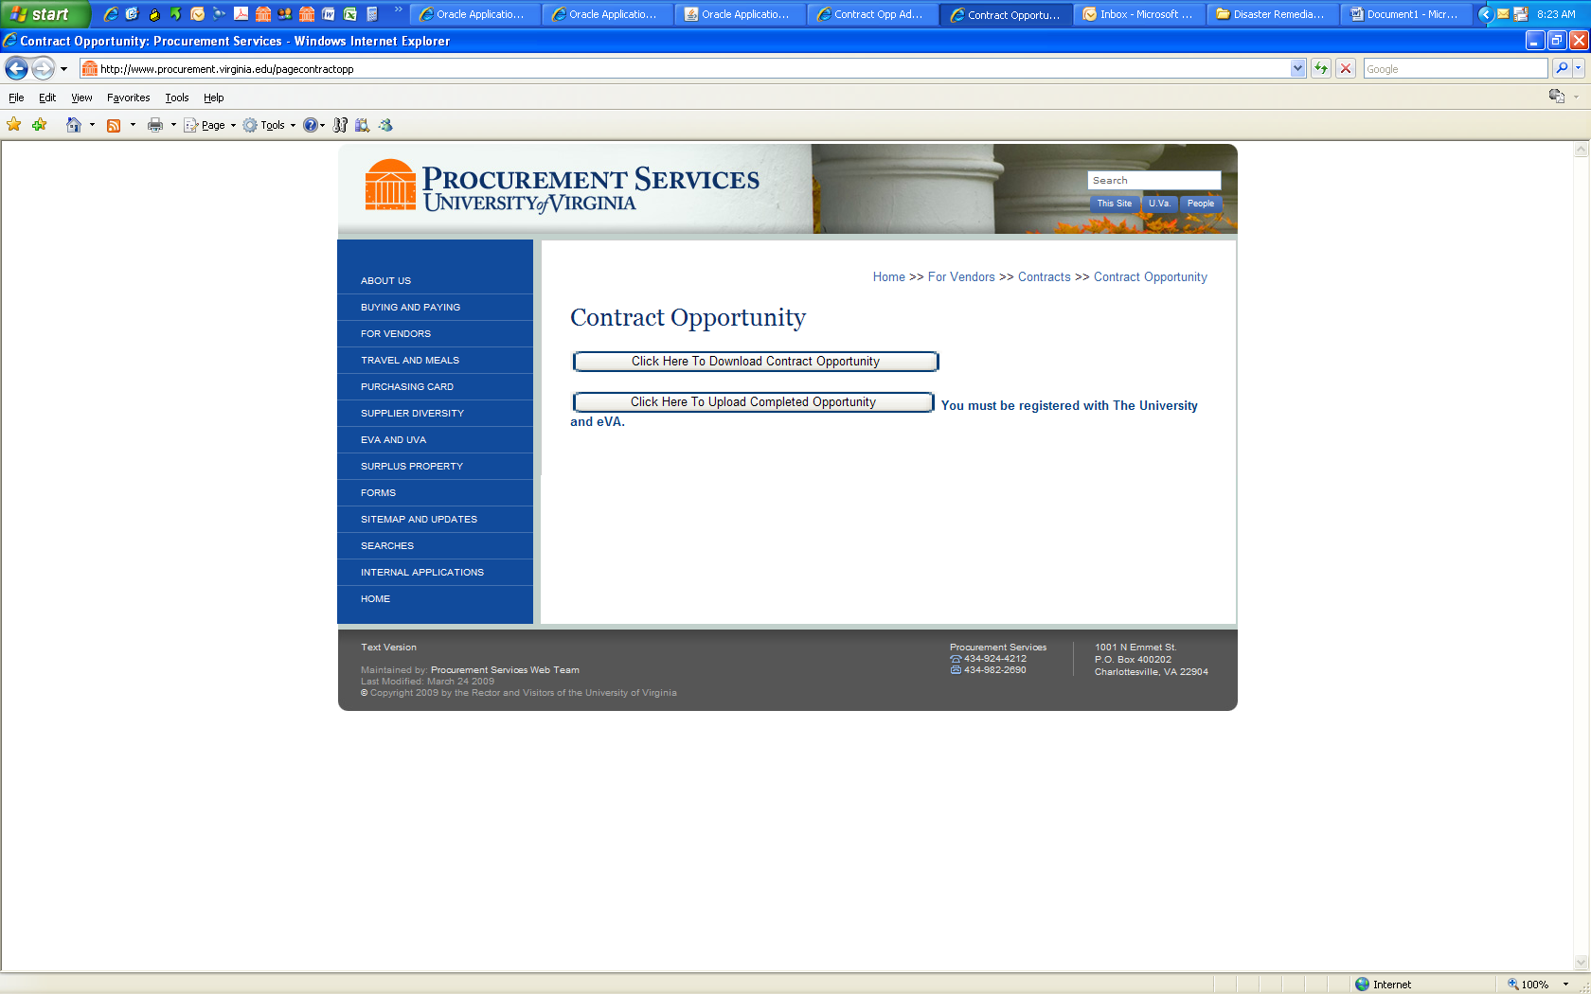

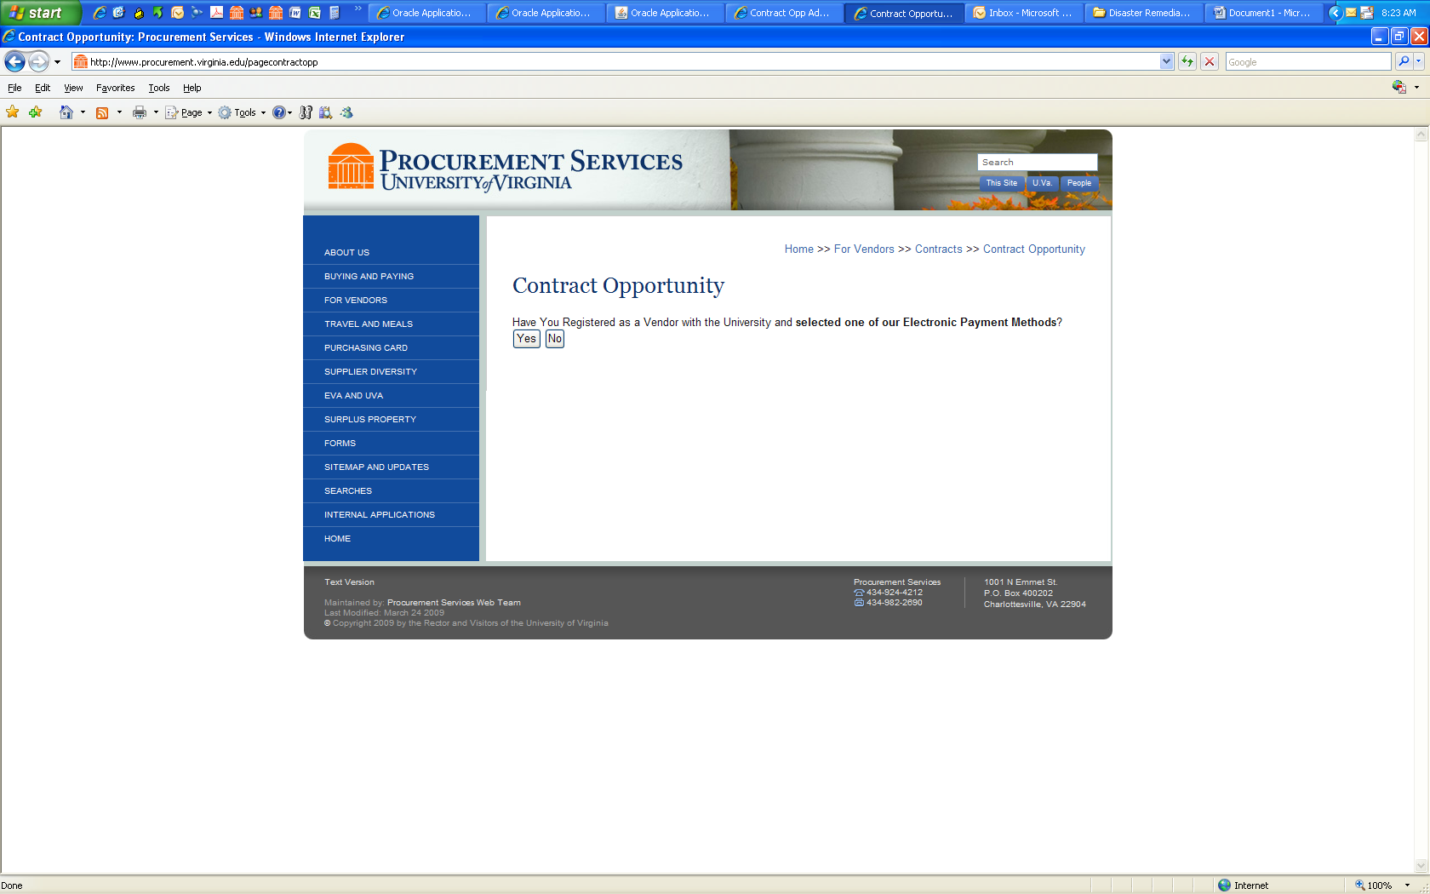

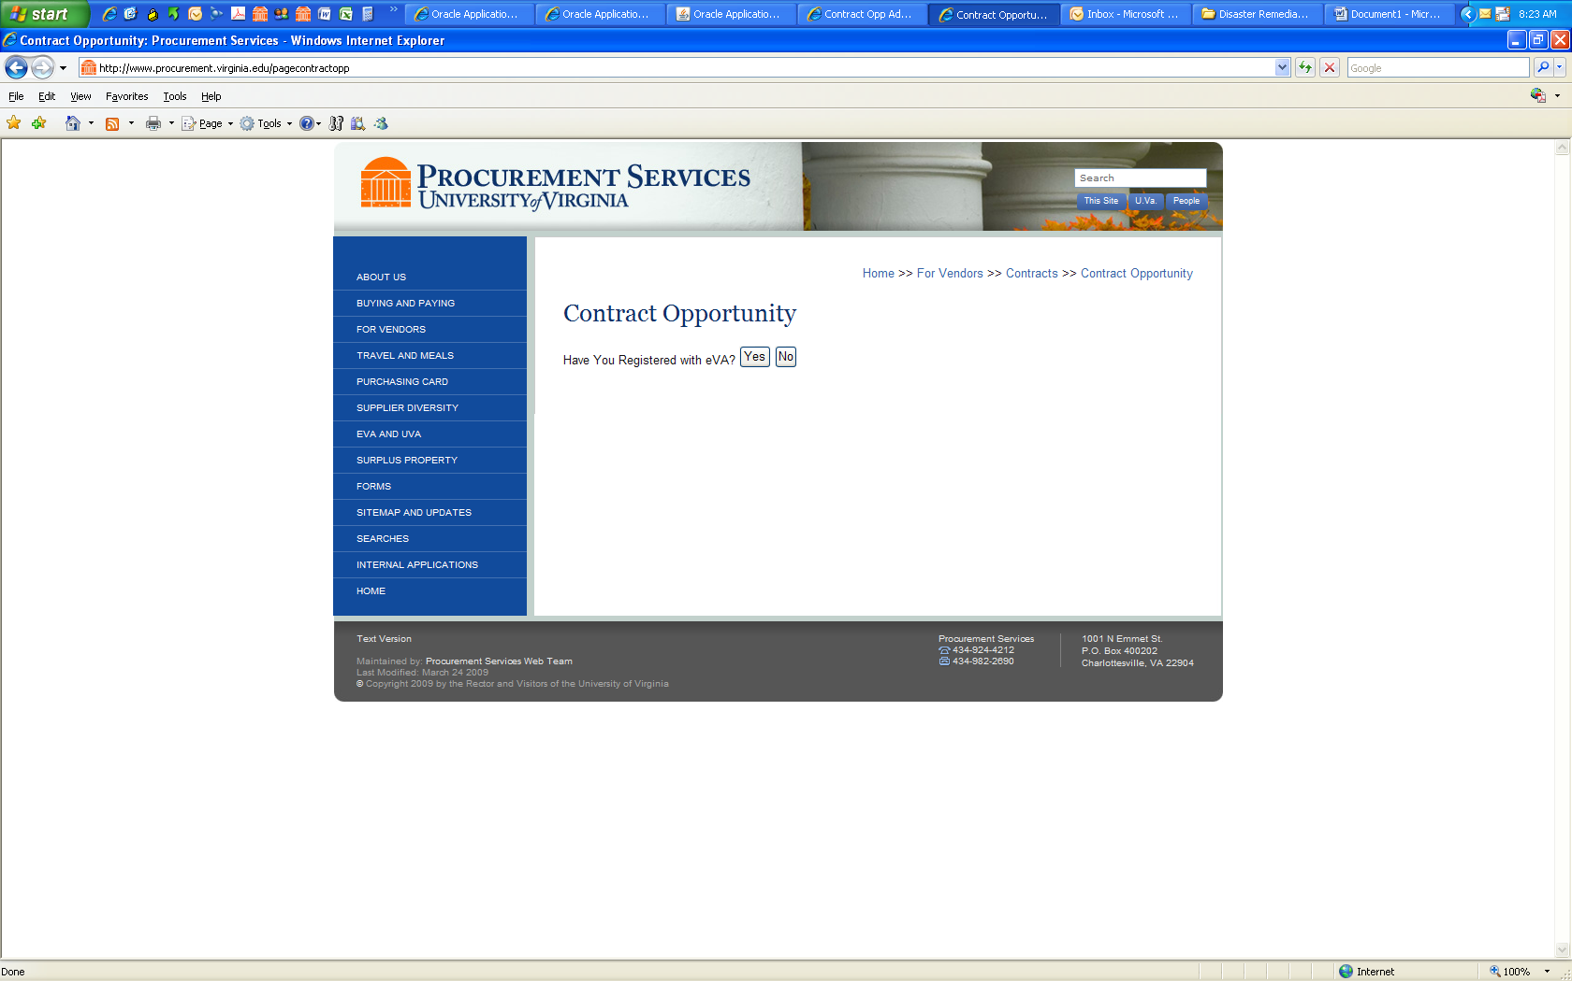

Complete the Vendor Information for the Customer Service Contact for the University (this information will be used to generate your Contract Summary page.

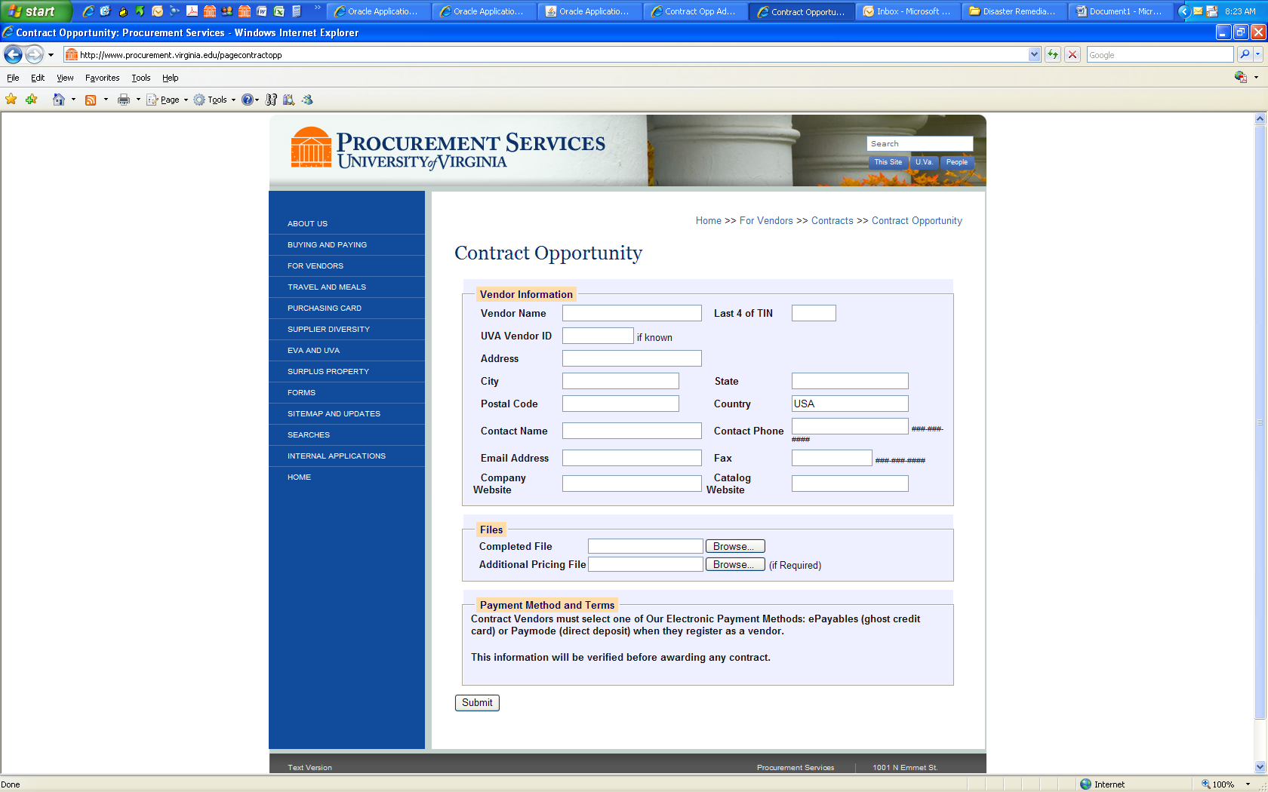

Clicking the ‘Submit’ button completes the response process for a Contract Opportunity.